Chapter 15, Solution 19.

Since 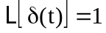 and  